# Task Description

Apart from the earlier work, we will make this site interactive. To do so, let’s make the sections below workable.

## Location

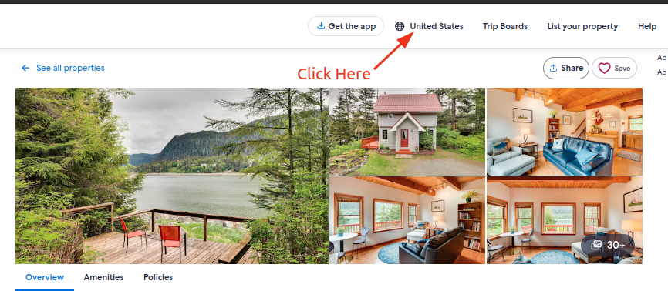

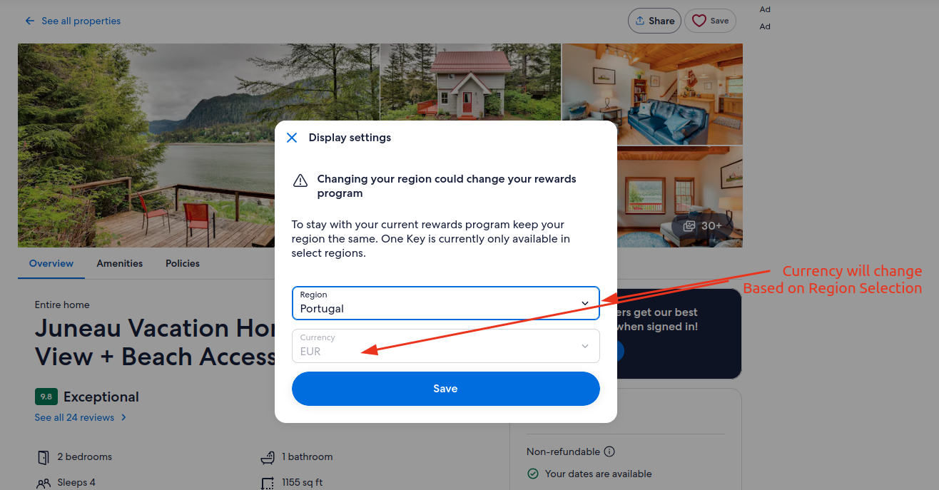

## Guests

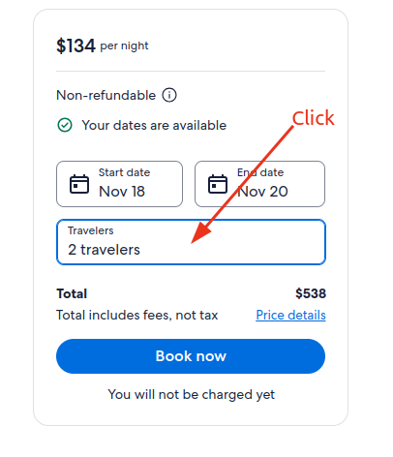

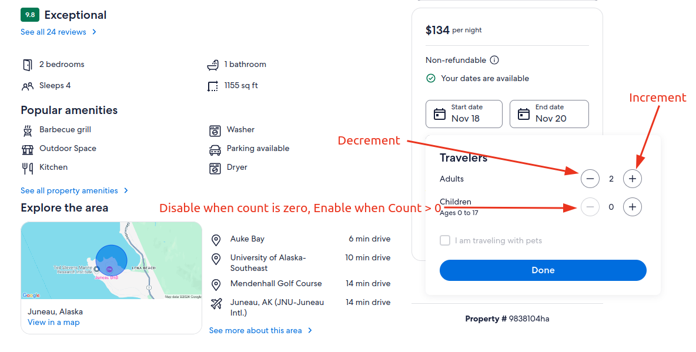

## Gallery

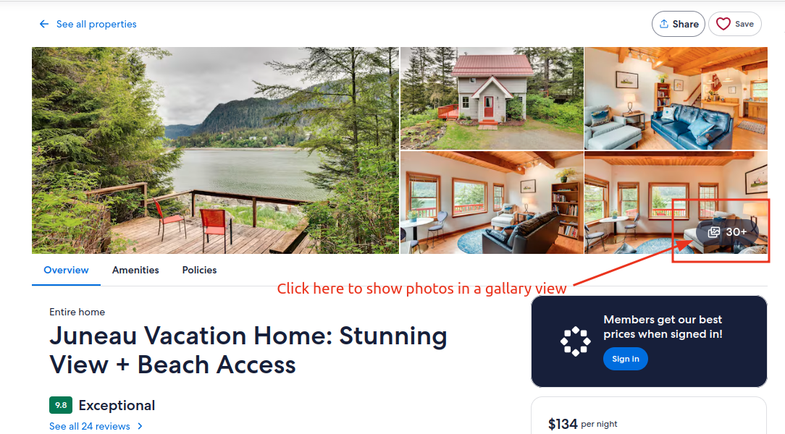

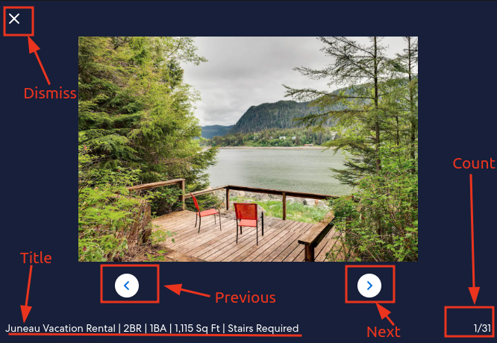

## Share

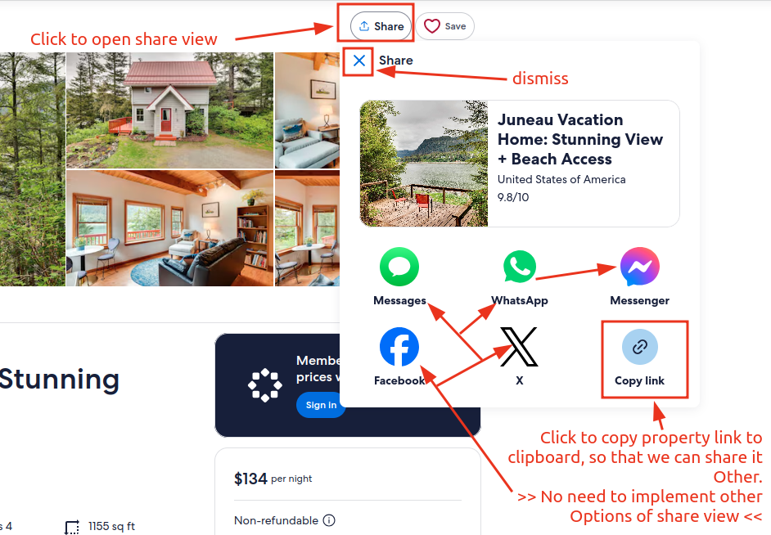

## Favorite

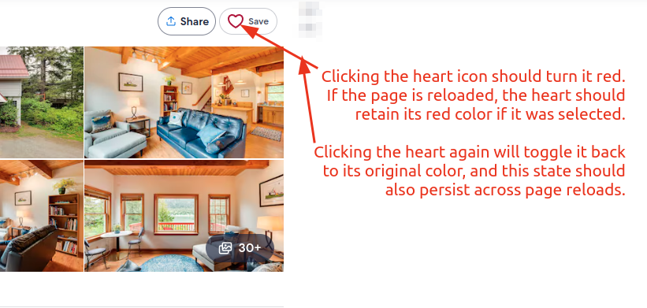

# Acceptance criteria

1. Below technology/tools must be used
   1. [HTML5](https://developer.mozilla.org/en-US/docs/Web/Guide/HTML/HTML5)
   2. [CSS](https://www.w3.org/Style/CSS/Overview.en.html)
   3. [Javascript](https://developer.mozilla.org/en-US/docs/Web/JavaScript)
2. UI Design should be mobile friendly (Responsive)
3. Must send a Github repo link which is public and contains a README.md
4. No cheating, will be disqualified
5. No use of 3rd party Javascript framework. E.g. Jquery, Vue, React. Only [**vanilla JS**](https://www.javatpoint.com/what-is-vanilla-javascript) is acceptable this time. For calendar or slider use libraries supported by vanilla js.

**Notes:**

The more you make it interactive and easy to use, will get more marks. You should focus on optimization while using DOM manipulation.

# Deadline

8th November 2024 **Friday 5 PM**